

Mirantis Research – POC
Includes an Overview of Mirantis Product and what is offered by Mirantis.

Prepared By : | Tharindu Kalhara
Intern – Cloud & DevOps Platforms
24.04.2026

Contents
Mirantis Overview 7
Background and History 7
What is Mirantis? 7
The Problems Mirantis Solves 7
The Core Products 8
1. k0s 8
2. K0rdent 8
3. Lens (Kubernetes IDE) 9
4. Mirantis Secure Registry (MSR) 10
5. Mirantis Container Runtime (MCR) 10
6. Mirantis Kubernetes Engine (MKE) 10
7. Mirantis OpenStack for Kubernetes (MOSK) 10
8. Mirantis Container Cloud (MCC) 11
Mirantis Open-Source Ecosystem 12
1. k0rdent - Distributed Container Management Environment 12
2. k0s - The Simplest Kubernetes Distribution 12
3. k0smotron - Kubernetes Control Planes as Pods 12
4. Lens IDE – World's Most Popular Kubernetes IDE 12
Metal-to-Model Stack 13
1. MCR + MSR 13
2. MOSK 13
3. MKE/kOs 13
4. kordent 14
5. GPU PaaS 14
6. Al PaaS 14
High Level Architecture 15
1. Infrastructure 15
2. Mirantis OpenStack for Kubernetes (MOSK) 15
3. Mirantis Container Runtime (MCR) 16
4. Mirantis Kubernetes Engine (MKE) 16
5. Mirantis Secure Registry (MSR) 16
6. Lens Desktop 16
k0rdent Enterprise Overview 16
Key Technical Terms/Concepts 17
1. Cluster API (CAPI) 17
2. k0s 17
3. k0smotron 17
4. GitOps 18
5. OCI / Container Image 18
6. Ingress / CNI / CSI 18
Mirantis vs OpenShift 18
Learning Curve 19
Domain 1 - Linux & System Administration 19
• File system & permissions 19
• systemd & services 19
• Networking tools 19
• SSH & key management 19
• Package management 20
• Disk & storage tools 20
• Text editing & scripting 20
• Cron & task scheduling 20
Domain 2 – Networking Fundamentals 20
• IP addressing & subnets 20
• VLANs 20
• Routing - L2 vs L3 20
• DNS 20
• NTP / time sync 20
• Firewalls & iptables / nftables 20
• BGP basics 21
• Load balancing concepts 21
• MTU & jumbo frames 21
• TLS / PKI 21
Domain 3 – Docker & Containers 21
• Container basics 21
• Docker CLI 21
• Images & layers 21
• Volumes & bind mounts 21
• Container networking 21
• Container registries 21
Domain 4 – Kubernetes 22
• Core objects 22
• Services & networking 22
• kubectl CLI 22
• Namespaces 22
• ConfigMaps & Secrets 22
• Persistent Volumes (PV/PVC) 22
• Helm charts 22
• Custom Resource Definitions (CRDs) 22
• RBAC 22
• Resource requests & limits 22
• Taints, tolerations & affinity 22
• kubectl troubleshooting 23
Domain 5 – OpenStack Services 23
• Keystone - identity 23
• Nova - compute 23
• Neutron - networking 23
• Glance - image service 23
• Horizon - dashboard 23
• Heat - orchestration 23
• Octavia - load balancing 23
• Ironic - bare metal 23
• Manila - shared filesystems 23
• openstack CLI & python-openstackclient 24
Domain 6 – Storage 24
• Ceph architecture 24
• Pools & placement groups 24
• RBD - block devices 24
• Rook operator for Kubernetes 24
• Ceph health & commands 24
• S3 / RadosGW 24
• CephFS 24
Domain 7 – Networking in MOSK – OVN / OpenSDN 24
• Open Virtual Network (OVN) concepts 24
• Overlay networks (VXLAN/Geneve) 24
• Floating IPs 25
• Security groups 25
• Provider networks 25
• MetalLB 25
• OpenSDN (Tungsten Fabric) 25
Domain 8 – IaC & Automation 25
• YAML fundamentals 25
• Helm deep dive 25
• Terraform with OpenStack provider 25
• Ansible basics 25
• Git & version control 25
• Bash scripting 26
• Python basics 26
Domain 9 – Monitoring & Observability 26
• Prometheus concepts 26
• Grafana dashboards 26
• Alertmanager 26
• Log aggregation 26
• Kubernetes events 26
• OpenStack service logs 26
Domain 10 – Security 26
• TLS certificate management 26
• Kubernetes RBAC 27
• OpenStack RBAC & quotas 27
• CIS benchmarks 27
• Secrets management 27
• Network policies 27
• FIPS 140-2 27

Mirantis Overview

Background and History
Founded in 2010, Mirantis began as an OpenStack-focused company, helping enterprises build and manage private cloud infrastructure. Over the following decade, it evolved significantly, expanding its OpenStack roots into a full-spectrum Kubernetes and AI infrastructure platform provider, establishing itself as a global leader in cloud-native infrastructure.
In 2019, Mirantis made a pivotal acquisition by purchasing Docker Enterprise, gaining the Mirantis Kubernetes Engine (MKE) and inheriting a large, established enterprise customer base. These moves transformed Mirantis into one of the most comprehensive container orchestration solutions available. The company further expanded its portfolio by acquiring Lens IDE - the world's most popular Kubernetes desktop tool - giving developers and platform teams a powerful, user-friendly interface for managing Kubernetes clusters.

What is Mirantis?
Mirantis is an enterprise cloud-native platform provider specializing in Kubernetes, OpenStack, and container technologies. It operates under a "Metal-to-Model" philosophy delivering every layer of the modern infrastructure stack, from bare-metal automation and GPU provisioning, through Kubernetes orchestration, all the way to AI model serving. Built on open-source foundations, it gives enterprises full control over their infrastructure without locking them into any single vendor.

The Problems Mirantis Solves
- Vendor Lock-In - Companies pay huge licensing fees to VMware, RedHat, or hyperscalers. Mirantis provides open-source alternatives (k0s, k0rdent) with enterprise support - no lock-in.
- Kubernetes Complexity - Running K8s at scale across hybrid clouds is operationally exhausting. Mirantis automates cluster lifecycle, multi-cloud management, and upgrade cycles.

- Hybrid/Multi-Cloud Chaos - Teams juggle disparate tools across AWS, Azure, GCP, and on-prem. k0rdent provides a single control plane to manage clusters anywhere, uniformly.
- AI Infrastructure Gap - Deploying GPU workloads for AI/ML demands specialized infrastructure. Mirantis delivers GPU PaaS with NVIDIA-validated stacks for training and inference.
- Security & Compliance - Enterprise security teams need image scanning, RBAC, audit logs. Mirantis Secure Registry and MKE provide hardened, compliance-ready container workflows.
- Legacy VM Migration - Companies still run thousands of VMs on VMware. MOSK (Mirantis OpenStack for Kubernetes) provides a migration path to containerized, modern infrastructure.

The Core Products

k0s
- Platform - https://www.mirantis.com/software/k0s/
- Documentation - https://docs.k0sproject.io/stable/
k0s is a zero-friction, single-binary K8s distribution. And it is open-source, CNCF-certified Kubernetes distribution from Mirantis, packaged as a single lightweight binary with zero host OS dependencies beyond the Linux kernel. It runs locally on any Linux machine (x86/ARM), edge devices, or even a single-node setup.

K0rdent
- Platform - https://www.mirantis.com/why-k0rdent/
- Documentation - https://docs.k0rdent.io/latest/
k0rdent is a Kubernetes-native, open-source platform for distributed container management and platform engineering. It serves as a “super control plane” the brain of the Mirantis platform providing centralized intelligence and control across complex environments.
It enables organizations to manage multi-cluster fleets across any cloud (like AWS or Azure), on-premises infrastructure, or edge environments, ensuring consistent operations at scale. Using declarative templates, k0rdent allows teams to standardize how clusters and AI workloads are defined, deployed, and managed.
As a 100% open-source solution, k0rdent is available on GitHub under permissive licenses, offering flexibility, extensibility, and enterprise-ready capabilities.
It has three main parts:
Component | What it Does | Details
Cluster Manager | Creates and updates clusters. | Connects directly to your cloud or hardware.
State Manager | Keeps apps running correctly. | Ensures security rules are followed everywhere.
Observability | Monitoring and cost tracking. | Helps you see how much money and power you are using.

Lens (Kubernetes IDE)
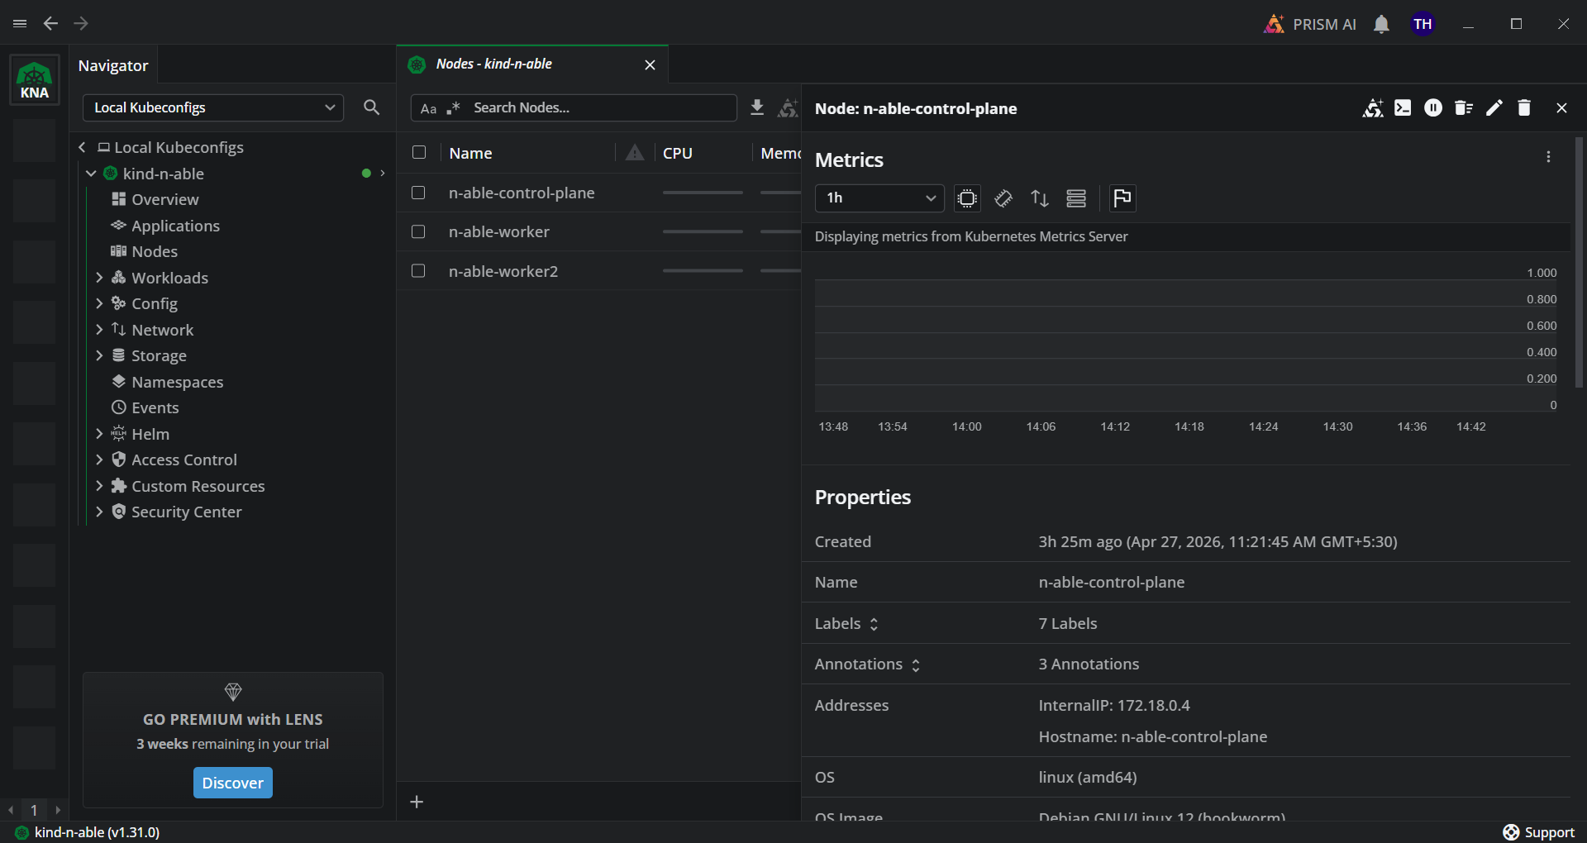
A desktop application that provides developers with a highly visual, intuitive dashboard to monitor and troubleshoot their cluster workloads without needing deep kubectl expertise.
Download - https://lenshq.io/

Mirantis Secure Registry (MSR)
- Platform - https://www.mirantis.com/software/mirantis-secure-registry/
- Documentation - https://docs.k0rdent.io/latest/ , https://docs.mirantis.com/msr/2.9/ref-arch/intro.html
This is the enterprise image repository. MSR Stores your CVEs, cryptographically signs trusted images, and uses policies to prevent vulnerable code from being deployed by scanning for viruses and bugs. Apps can only go live if they are proven to be safe.

Mirantis Container Runtime (MCR)
- Platform - https://www.mirantis.com/software/mirantis-container-runtime/
- Documentation - https://docs.mirantis.com/mcr/25.0/single/
containerd-based container runtime. Powers MKE and integrates with MSR. Enterprise-supported replacement for Docker Engine. This is the foundational container engine in Mirantis and includes native support for Windows, Linux, and multi-platform images.

Mirantis Kubernetes Engine (MKE)
- Platform - https://www.mirantis.com/software/mirantis-container-runtime/
- Documentation - https://docs.mirantis.com/mke/3.5/single/
The Mirantis Kubernetes Engine (MKE) is the Enterprise Kubernetes Engine built on k0s that runs your containers. This is the central orchestrator (formerly Docker Enterprise). It is built to be fast, secure, and work on any cloud. Secure, composable, production-grade container orchestration.

Mirantis OpenStack for Kubernetes (MOSK)
- Platform - https://www.mirantis.com/software/mirantis-openstack-for-kubernetes/
- Documentation - https://docs.mirantis.com/mke/3.5/single/

MOSK sits directly on top of bare metal infrastructure, transforming physical hardware into a fully functional on-premise cloud. As an Infrastructure-as-a-Service (IaaS) platform, it virtualizes compute, networking, and storage resources - breaking them down into virtual machines, virtual networks, and block storage. Built with a cloud-native approach, MOSK is containerized and managed using Kubernetes operators, enabling automated deployment and lifecycle management. This allows organizations to efficiently provision and operate private clouds on bare metal with the scalability, consistency, and control of modern cloud environments.

Mirantis Container Cloud (MCC)
Multi-cloud management. Provisions and manages lifecycle of MKE and MOSK clusters across bare metal and public clouds.
Documentation- https://www.releaseteam.com/downloads/mirantis/mirantis_container_cloud_datasheet.pdf

Mirantis Open-Source Ecosystem

k0rdent - Distributed Container Management Environment
100% open-source. Build, automate and manage IDPs for any workload on any infra. Composable, declarative. Foundation of k0rdent Enterprise.

k0s - The Simplest Kubernetes Distribution
Single binary, zero external dependencies. Runs anywhere. Used in production by thousands. Maintained by Mirantis.

k0smotron - Kubernetes Control Planes as Pods
Runs full K8s control planes inside an existing cluster. Dramatically reduces resource overhead for multi-tenant platforms.

Lens IDE – World's Most Popular Kubernetes IDE
1M+ users. Real-time cluster visualization, multi-cluster management, extensions marketplace. Available free and via Lens Pro.

Metal-to-Model Stack
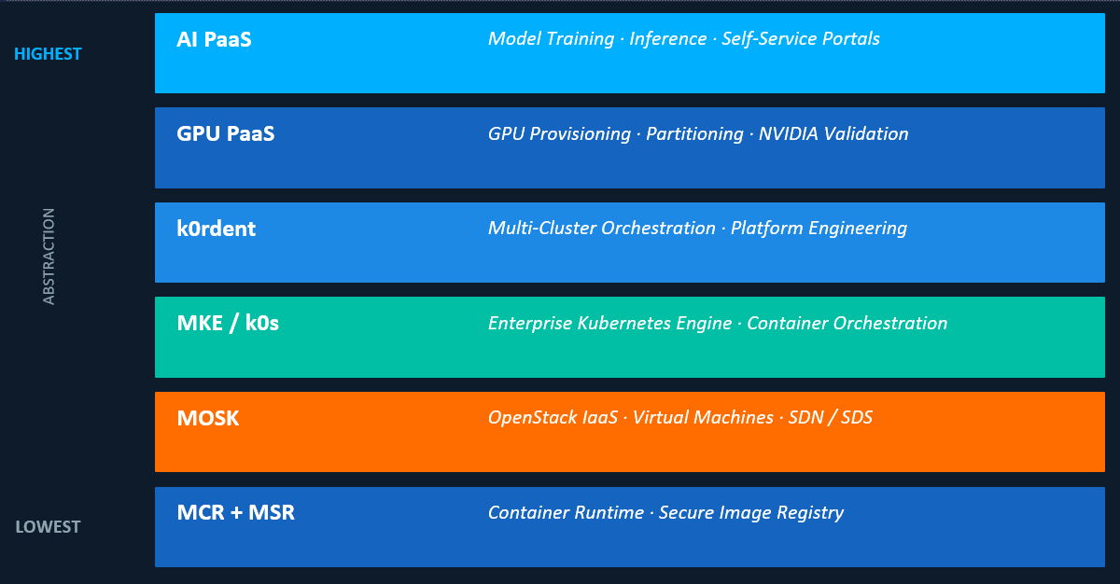

MCR + MSR
Lowest abstraction. The Mirantis Container Runtime executes the containers, while the Mirantis Secure Registry ensures all images are scanned and cryptographically signed.

MOSK
OpenStack laas. Provides the private cloud infrastructure, virtual machines, and software-defined networking/storage (SDN/SDS) on top of raw bare metal.

MKE/kOs
Enterprise Kubernetes Engine and Container Orchestration. The universal mid-layer that schedules the containerized Al workloads across the available compute resources.

kordent
Multi-cluster orchestration and platform engineering. Acts as the control plane to manage the lifecycle of the specialized Al and GPU clusters running below it.

GPU PaaS
Bridges the Kubernetes layer with physical Al hardware. Handles GPU provisioning, partitioning (vGPU), and NVIDIA validation to ensure maximum hardware utilization.

Al PaaS
Highest abstraction layer. Provides self-service portals for data scientists, model training environments, and inference endpoints.
Replaces traditional DevOps delivery tools in an Al-specific stack.

High Level Architecture
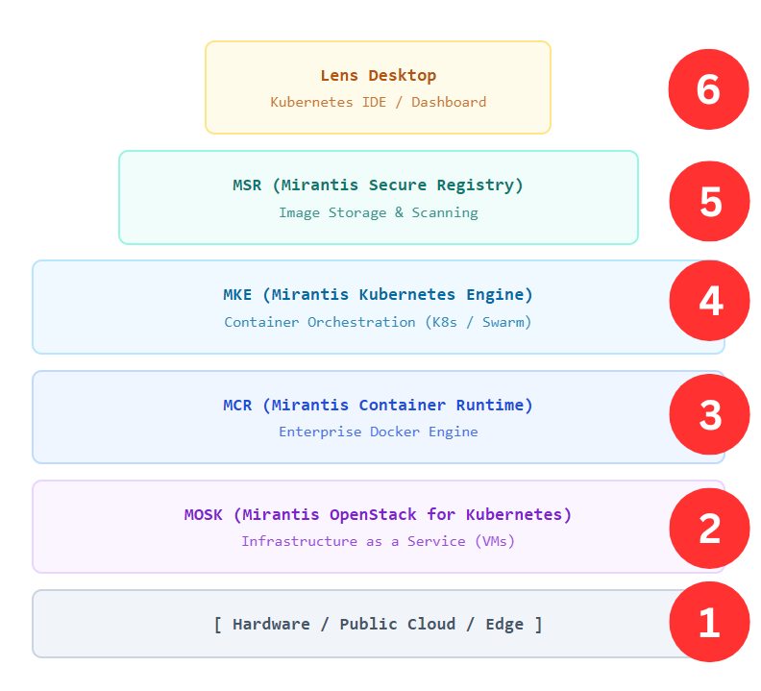

Infrastructure
The physical servers, storage arrays, networking gear, or underlying public cloud instances (like AWS EC2) that provide the raw compute power for the entire Mirantis stack.

Mirantis OpenStack for Kubernetes (MOSK)
A complete Cloud Operating System. Uniquely, Mirantis deploys OpenStack services AS containers inside Kubernetes. MOSK allows your company to spin up Virtual Machines on demand, acting like your own private AWS.

Mirantis Container Runtime (MCR)
The foundational software installed directly on the operating system. MCR provides the actual environment needed to start, stop, and run a container process. It is highly secure and FIPS certified.

Mirantis Kubernetes Engine (MKE)
The Orchestrator. MKE groups multiple servers together to form a cluster. It schedules where containers should run, handles networking, and ensures high availability. It runs ON TOP of MCR.

Mirantis Secure Registry (MSR)
Where container images live. Before MKE can run a container, it pulls the image from MSR. MSR scans these images for security vulnerabilities.

Lens Desktop
The top layer. Lens connects to MKE (or any K8s cluster) via an API. It provides a graphical interface so developers don't have to memorize hundreds of command-line instructions. It is the easiest product to start with.

k0rdent Enterprise Overview
Kubernetes-native platform engineering. Manages multi-cluster fleets across any cloud, on-prem or edge. The 'brain' of the Mirantis platform.
- Declarative, GitOps-driven cluster management
- Multi-cluster fleet management at scale
- Supports AWS, Azure, GCP, on-prem, bare metal
- Composable - plug in any tool or service
- Internal Developer Platform (IDP) builder
- 100% open-source k0rdent at the core
- Enterprise version adds security & 24/7 support
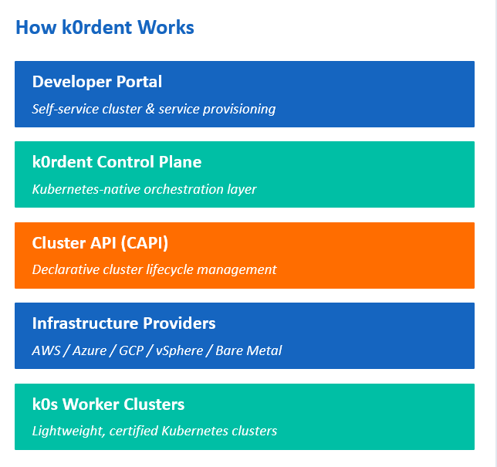

Key Technical Terms/Concepts

Cluster API (CAPI)
Kubernetes sub-project for declarative cluster lifecycle management. k0rdent uses CAPI providers to provision clusters on any infrastructure.

k0s
Zero-friction, single-binary Kubernetes distribution by Mirantis. No external dependencies. Free and open source. Runs on x86, ARM64, ARMv7.

k0smotron
Kubernetes-in-Kubernetes controller. Runs K8s control planes as pods inside a host cluster ultra-efficient for multi-tenant environments.

GitOps
Operational model where Git is the source of truth. Cluster state declared in Git, continuously reconciled by k0rdent. Enables audit trails and rollbacks.

OCI / Container Image
Open Container Initiative standard for images. MSR stores, scans, and distributes OCI-compliant images with policy enforcement.

Ingress / CNI / CSI
Core Kubernetes extension points: Ingress (traffic routing), CNI (networking), CSI (storage). MKE ships with curated, enterprise-tested integrations.

Mirantis vs OpenShift
At a high level, Mirantis and Red Hat OpenShift solve the same core problem (enterprise Kubernetes), but they take very different approaches in philosophy, ecosystem, and control.
Aspect | Mirantis | OpenShift
Core Idea | Kubernetes platform with flexibility | Opinionated enterprise Kubernetes platform
Philosophy | Open, modular, bring-your-own tools | Integrated, all-in-one ecosystem
Vendor | Mirantis | Red Hat
Base | Kubernetes + Docker Enterprise | Kubernetes + Red Hat ecosystem
Lock-in | Low | Moderate
Ease of Use | Medium | High
Customization | High | Limited (by design)
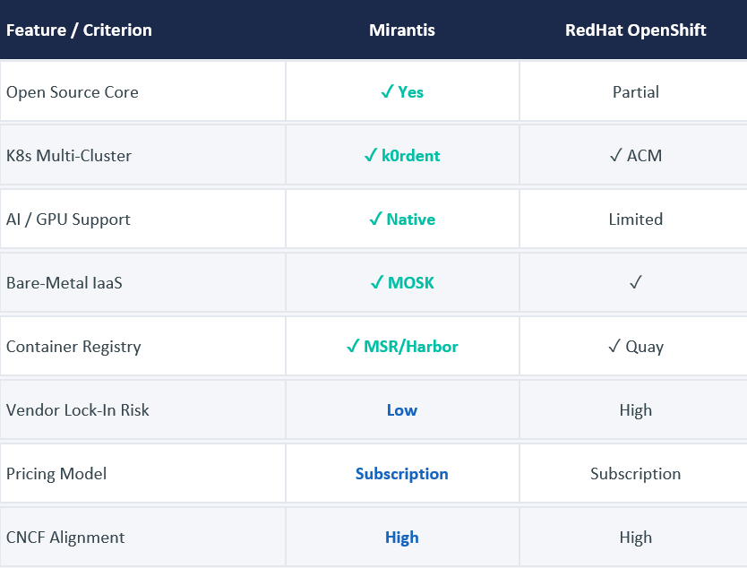

Learning Curve

Domain 1 - Linux & System Administration

File system & permissions
Understand /etc, /var, /opt, chmod, chown, file ownership - MOSK config files live here

systemd & services
Start/stop/status services with systemctl; read logs with journalctl -u

Networking tools
ip addr, ip route, ss -tulnp, ping, traceroute, curl - diagnose connectivity issues

SSH & key management
SSH into nodes, manage ~/.ssh/authorized_keys, use ssh-keygen, understand key-based auth

Package management
apt install/update/upgrade on Ubuntu; understand apt pinning to prevent accidental upgrades

Disk & storage tools
lsblk, fdisk, df -h, du - understand partitions, mounts, and how disks are presented to the OS

Text editing & scripting
Comfortable in vim or nano; write basic bash scripts for automation

Cron & task scheduling
Set up cron jobs for backups and health checks

Domain 2 – Networking Fundamentals

IP addressing & subnets
CIDR notation (e.g. 192.168.1.0/24), calculate usable IPs, understand broadcast and gateway

VLANs
How VLANs segment a physical network; VLAN tagging (802.1Q); trunk vs access ports on switches

Routing - L2 vs L3
L2 = same subnet, forwarded by MAC; L3 = different subnets, forwarded by IP routing tables

DNS
How name resolution works; /etc/hosts, /etc/resolv.conf; forward and reverse DNS; why it must be correct

NTP / time sync
Why synchronized clocks matter for TLS certs and Keystone tokens; configure chrony or ntpd

Firewalls & iptables / nftables
Basic firewall rules; understand how security groups in OpenStack map to iptables rules

BGP basics
MOSK 25.x uses BGP to advertise service IPs across racks - understand what BGP is and what a route advertisement looks like

Load balancing concepts
Virtual IPs (VIPs), keepalived/VRRP for HA, MetalLB for Kubernetes service exposure

MTU & jumbo frames
Ceph and overlay networks need correct MTU (often 9000 for storage); misconfigured MTU causes subtle packet loss

TLS / PKI
How certificates work, CA chains, OpenSSL commands to inspect certs; MOSK uses TLS everywhere

Domain 3 – Docker & Containers

Container basics
What a container is vs a VM; namespaces and cgroups as isolation primitives

Docker CLI
docker run, docker ps, docker logs, docker exec, docker inspect - inspect running OpenStack containers

Images & layers
How images are built from layers; Dockerfile structure; image registries (Docker Hub, private registries)

Volumes & bind mounts
How containers persist data; understand bind mounts vs named volumes

Container networking
Bridge networks, host networking, port mappings; how containers talk to each other

Container registries
Push/pull images; set up a private registry for air-gapped MOSK deployments

Domain 4 – Kubernetes

Core objects
Pod, Deployment, ReplicaSet, StatefulSet, DaemonSet - know what each does and when each is used

Services & networking
ClusterIP, NodePort, LoadBalancer service types; how kube-proxy routes traffic; Endpoints objects

kubectl CLI
get, describe, logs, exec, apply, delete - you'll use these constantly to debug MOSK

Namespaces
MOSK deploys OpenStack into a dedicated namespace; understand resource isolation and RBAC per namespace

ConfigMaps & Secrets
How MOSK stores OpenStack config and credentials; never store secrets in plain YAML

Persistent Volumes (PV/PVC)
How Kubernetes requests storage; StorageClasses; how Ceph provides PVCs to OpenStack pods

Helm charts
MOSK uses Helm to package OpenStack services; understand values.yaml, helm install/upgrade/rollback

Custom Resource Definitions (CRDs)
Rockoon uses CRDs to define OpenStack cluster config; kubectl get openstackdeployments

RBAC
Roles, ClusterRoles, RoleBindings; who can do what inside the cluster; important for security hardening

Resource requests & limits
CPU and memory requests/limits on pods; how the scheduler places pods; QoS classes

Taints, tolerations & affinity
Control which nodes run which pods; MOSK uses these to separate controller vs compute workloads

kubectl troubleshooting
CrashLoopBackOff, ImagePullBackOff, Pending pods - read events: kubectl describe pod

Domain 5 – OpenStack Services

Keystone - identity
Projects, users, roles, tokens, service catalog; every API call authenticates through Keystone first

Nova - compute
VM lifecycle (create/start/stop/migrate/delete), flavors, hypervisors, scheduling, live migration

Neutron - networking
Networks, subnets, routers, floating IPs, security groups, port bindings; most complex OpenStack service

Glance - image service
Upload OS images (Ubuntu/CentOS cloud images), manage image visibility and formats (QCOW2, RAW)

Horizon - dashboard
Web UI for all of the above; understand projects, quotas, launch wizard

Heat - orchestration
Infrastructure-as-Code for OpenStack; like Terraform but native; define stacks in YAML

Octavia - load balancing
Create LBaaS (load balancer as a service) in front of VM pools; important for any HA app

Ironic - bare metal
Provision physical servers via OpenStack API; important if your company has bare-metal workloads

Manila - shared filesystems
NFS/CephFS shared file storage; optional MOSK add-on for apps needing shared volumes

openstack CLI & python-openstackclient
Command-line access to all services; essential for scripting and automation

Domain 6 – Storage

Ceph architecture
MON (monitors), OSD (object storage daemons), MGR (manager), MDS (for CephFS); understand quorum

Pools & placement groups
How data is distributed; replication factor (usually 3x); understand pool sizing

RBD - block devices
RADOS Block Device; how Cinder volumes become Ceph RBD images; attach to VMs

Rook operator for Kubernetes
MOSK uses Rook to deploy and manage Ceph inside Kubernetes; understand Rook CRDs

Ceph health & commands
ceph status, ceph osd tree, ceph df; diagnose HEALTH_WARN vs HEALTH_ERR

S3 / RadosGW
Ceph's object storage; used for OpenStack image backups and Manila; compatible with AWS S3 API

CephFS
Shared POSIX filesystem on top of Ceph; used by Manila for shared volume add-on

Domain 7 – Networking in MOSK – OVN / OpenSDN

Open Virtual Network (OVN) concepts
Logical switches, logical routers, ACLs - all implemented in software; OVN replaces OVS in MOSK

Overlay networks (VXLAN/Geneve)
How tenant VM traffic is encapsulated over the physical network; understand encapsulation overhead

Floating IPs
How external IPs are mapped to private tenant IPs via NAT; how to configure in Neutron

Security groups
Stateful firewall rules per VM port; understand ingress/egress direction; common MOSK day-1 task

Provider networks
Flat or VLAN networks that connect VMs directly to the physical network; required for bare metal

MetalLB
Kubernetes LoadBalancer implementation used by MOSK; announces VIPs via BGP or L2

OpenSDN (Tungsten Fabric)
Alternative to OVN in MOSK; more complex, used in telco environments; understand when to choose it

Domain 8 – IaC & Automation

YAML fundamentals
All Kubernetes manifests and Helm values are YAML; understand indentation, anchors, multiline strings

Helm deep dive
Templating with {{ .Values.x }}; override values files per environment; helm diff plugin

Terraform with OpenStack provider
Provision VMs, networks, volumes via code; terraform init/plan/apply/destroy; state management

Ansible basics
Write playbooks to configure nodes; roles; inventory files; ad-hoc commands; used heavily in MOSK ops

Git & version control
Every config file must be in git; branching strategy; pull request review before applying changes

Bash scripting
Automate repetitive tasks; parse JSON with jq; use openstack CLI in scripts

Python basics
Read/modify Python-based OpenStack tooling; write simple scripts using openstacksdk

Domain 9 – Monitoring & Observability

Prometheus concepts
Metrics, labels, PromQL queries; how MOSK exports metrics from all OpenStack and Kubernetes components

Grafana dashboards
Read pre-built MOSK dashboards; create custom panels; understand time series visualization

Alertmanager
Route alerts to email/Slack; understand silence and inhibition; configure critical MOSK alerts

Log aggregation
MOSK uses Loki or Elasticsearch for logs; kubectl logs for pod-level; understand log levels

Kubernetes events
kubectl get events --sort-by=.lastTimestamp -- first place to look when something breaks

OpenStack service logs
Nova/Neutron/Cinder logs inside containers; kubectl logs -n openstack -f

Domain 10 – Security

TLS certificate management
MOSK uses cert-manager for Kubernetes; understand how to renew, rotate, and troubleshoot certs

Kubernetes RBAC
Least-privilege access for operators; create service accounts for automation; audit who can do what

OpenStack RBAC & quotas
Limit what each project can consume; admin vs member vs reader roles in Keystone

CIS benchmarks
Industry standard security hardening for Linux, Docker, and Kubernetes - MOSK ships aligned to these

Secrets management
Never commit passwords to git; use Kubernetes Secrets or Vault; understand how MOSK stores DB passwords

Network policies
Kubernetes NetworkPolicy objects to restrict pod-to-pod traffic; isolate MOSK namespaces

FIPS 140-2
Cryptography compliance standard; MOSK supports FIPS mode for regulated industries (finance, gov)

Getting Started with Mirantis – First with k0s
k0s by Mirantis is a zero-friction, single-binary Kubernetes distribution that dramatically simplifies cluster deployment. It strips away the complexity of traditional K8s installations while remaining fully conformant and production-ready, making it an excellent lightweight choice for edge environments or streamlined cloud deployments.

